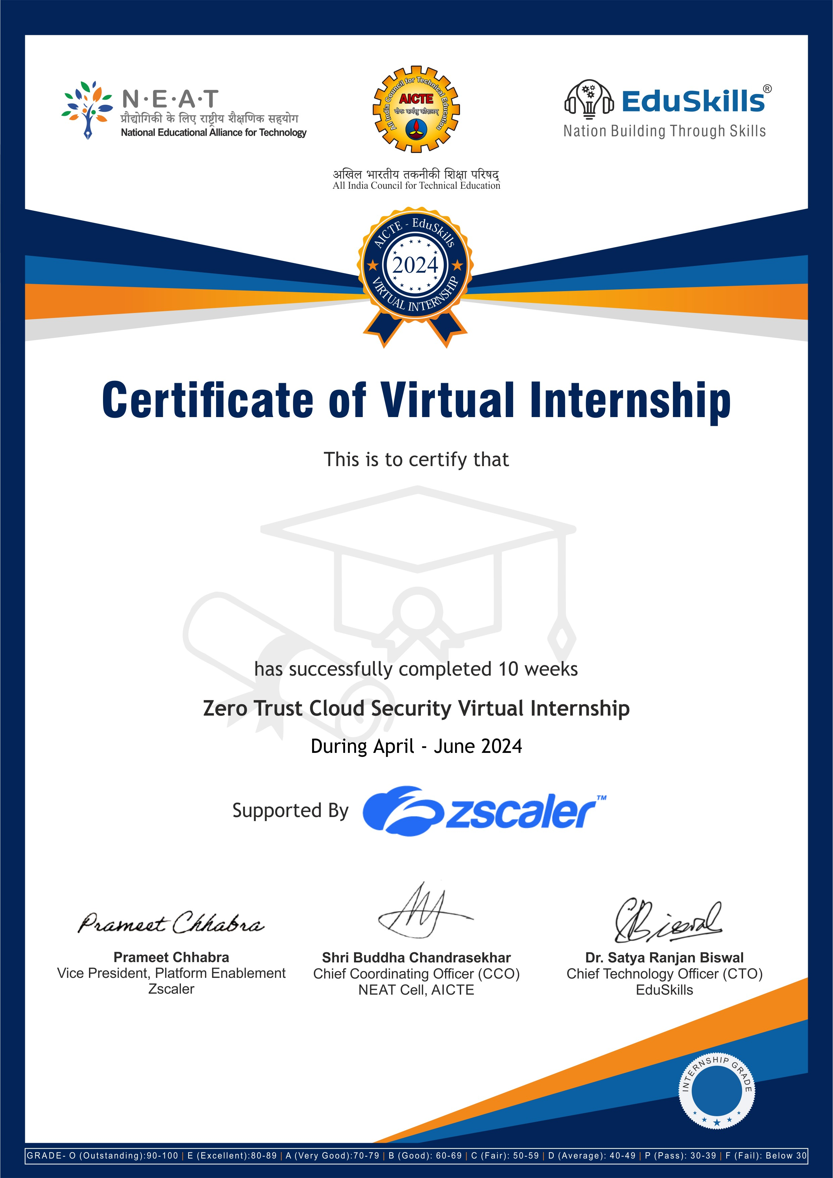

N SANJANA

SRI VENKATESWARA COLLEGE OF ENGINEERING AND TECHNOLOGY

AAND TECHNOLOGY

Certificate ID :6f3442e7aa7ee01cdd2f79a303f5ceb3

Student ID :STU641c3796184651679570838

E